A Report on

**MSP430 Based Project**

Titled

**Garbage Management System**

For

# Mini Project 2A (REV- 2019 ‘C’ Scheme) of Third Year, (TE Sem-V)

In

# Electronics & Telecommunication Engineering

By

1. A-07. Pranay Ramchandra Bedekar
2. A-10. Vipul Sudhakar Bhoge
3. A-19. Shraddha Nilesh Dhayde

Under the guidance of

 **Prof. Ishmeet Singh Riar**

# UNIVERSITY OF MUMBAI A. Y. 2021-22

**Mahatma Education Society’s Pillai College of Engineering Accredited A+ by NAAC**

## Dr. K. M. Vasudevan Pillai Campus,

**Plot No. 10, Sector-16, New Panvel - 410206**

**CERTIFICATE**

This is to certify that the **MSP430 Based Project** entitled **Garbage Management System** is a bonafide work of

1. A-07. Pranay Ramchandra Bedekar
2. A-10. Vipul Sudhakar Bhoge
3. A-19. Shraddha Nilesh Dhayde

submitted to the University of Mumbai in partial fulfillment of the requirement for the award of **Mini Project 2A (REV- 2019 ‘C’ Scheme) of Third Year, (TE Sem-V)** in **Electronics & Telecommunication Engineering** as laid down by **University of Mumbai** during academic year **2021-22**

( ) ( )

## Examiner/Reviewer-1 Examiner/ Reviewer -2

|  |  |  |
| --- | --- | --- |
| **Prof. Ishmeet Singh Riar** | **Dr. Avinash Vaidya** | **Dr. Sandeep Joshi** |
| **Guide** | **Head of Department** | **Principal** |

**ABSTRACT**

With increase in population, the scenario of cleanliness with respect to garbage management is degrading tremendously. The overflow of garbage in public areas creates the unhygienic condition in the nearby surrounding. It may provoke several serious diseases amongst the nearby people. It also degrades the valuation of the area. To avoid this and to enhance the cleaning, ‘garbage management system’ is proposed in this paper. In the proposed system, the level of garbage in the dustbins is detected with the help of Sensor systems, and communicated to the authorized control room through GSM system. Msp430 is used to interface the sensor system with GSM system. This will help to manage the garbage collection efficiency.…………………..………………………………………..

# LIST OF FIGURES

|  |  |  |
| --- | --- | --- |
| **Figure**  **No.** | **Name of the figure** | **Page**  **No.** |
| 4.1 | Block Diagram of Garbage Management System. | 5 |
| 4.2 | Circuit Diagram of Garbage Management System. | 6 |
| 5.1 | MSP430. | 8 |
| 5.2 | IR Sensor | 9 |
| 5.3 | Ultrasonic Sensor | 10 |
| 5.4 | GSM Modem | 11 |
| 5.5 | Rain Sensor | 11 |
| 6.1 | Diagram of Garbage Management System | 13 |
| 7.1 | Diagram of initial state of garbage management system. | 14 |
| 7.2 | Diagram of working state of garbage management system. | 14 |
| 7.3 | Diagram of sends a message to municipal office of garbage management system. | 15 |

**LIST OF TABLES**

|  |  |  |
| --- | --- | --- |
| **Table**  **No.** | **Table Title** | **Page**  **No.** |
| 5.1 | List of Hardware Components. | 7 |

**LIST OF ABBREVIATIONS**

|  |  |
| --- | --- |
| IR | Infrared |
| LED | Light emitting diode |
| UT | Ultrasonic |

**LIST OF SYMBOLS**

|  |  |
| --- | --- |
| Ω | Ohms |

**INDEX**

|  |  |  |  |
| --- | --- | --- | --- |
| **CONTENTS** | | | |
| Certificate | | …………………………………………………………………... | i |
| Abstract | | …………………………………………………………………... | ii |
| List of Figures | | …………………………………………………………………... | iii |
| List of Tables | | …………………………………………………………………... | iv |
| Abbreviation | | …………………………………………………………………... | v |
| List of Symbols | | …………………………………………………………………... | vi |
|  | |  |  |
| 1. | Introduction ………………………………………………………………  1.1 Basics of Garbage Management System | | 1 |
| 2. | Literature Review………………………………………………………… | | 2 |
| 3. | Problem Statement ………………………………………………………   * 1. Need   2. Objectives | | 3 |
| 4. | Principle and Working ……………………………………………………   * 1. Block diagram   2. Circuit diagram | | 4 |
| 5. | Component Description ……………………………………………………   * 1. Hardware   2. Software | | 7 |
| 6. | Software Implementation …………………………………………………. | | 13 |
| 7. | Simulation Results ………………………………………………………… | | 14 |
| 8. | Conclusions ………………………………………………………………. | | 16 |
| 9. | Future Scope ………………………………………………………………. | | 17 |
| References | | …………………………………………………………………... | 18 |
| Appendix | | …………………………………………………………………... | 19 |

**CHAPTER 1 INTRODUCTION**

Waste management is all the activities and actions required to manage waste from its inception to its final disposal. This includes collection, transportation, treatment and disposal of waste together with monitoring and regulation.

Waste collection methods vary widely among different countries and regions. Domestic waste collection services are often provided by local government authorities. Curbside collection is the most common method of disposal in most countries, in which waste is collected at regular intervals by specialized trucks. Waste collected is then transported to an appropriate disposal area.

Now days, cities with developing economies experience exhausted waste collection services, inadequately managed and uncontrolled dumpsites and the problems are worsening. Waste collection method in such countries is an on-going challenge and many struggle due to weak institutions and rapid urbanization.

## Basics of Garbage Management System.

## Sometimes, up to 60% of waste is not being collected; it is often simply burned by the roadside. It can pollute drinking water; it can spread disease to people living nearby.

## Waste management prevents harm to human health and the environment by reducing the volume and hazardous character of residential and industrial waste.

## Improving proper waste management will reduce pollution, recycle useful materials and create more green energy.

To avoid all such situations, we have designed this project called “Garbage Management System”. The Garbage Management System is a simple project, where the LED shows the status of the garbage level. The system uses ultrasonic sensors placed over the dustbin to detect the garbage level and compare it with the garbage dustbins depth. when dustbin has full then GSM Modem send a message to municipal office. The dustbin is full collect the garbage.

# CHAPTER 2 LITERATURE REVIEW

# 1) Internet of Things: Challenges and state of the art solutions in Internet-scale Sensor Information Management and Mobile analytics by Arkady Zaslavsky, Dimitrios Georgakopoulos. This paper gave us the details about mobile analysis and sensor information management that will help in data segregation of various dustbins.

# 2) Meghana K C, Dr. K.R. Natraj have equipped the smart bins with ultrasonic sensor which measure the level of dustbin being filled up. The container is divided into three levels of garbage being collected in it. Every time the garbage crosses a level the sensors receives the data of the filled level. This data is further sent to the garbage analyzer as instant message using GSM module.

# 3) Vishesh Kumar Kurrel has built a framework in which a camera will be set at each garbage collection point alongside load cell sensor at base of the trash can. The camera will take continuous snapshots of the garbage can. A threshold level is set which compare the output camera and load cell sensor. Accordingly, information is processed that is controller checks if the threshold level is exceeded or not. This is convenient to use but economically not reliable.

# 4) Smart Garbage Management System by Vikrant Bhor, Pankaj Morajkar, Maheshwar Gurav, Dishant Pandya. It provided us with additional details and designs needed for flow and management of garbage while collection.

ystem (GPS) [6].

# CHAPTER 3

**PROBLEM STATEMENT**

* The main concern with our environment has been waste management which impacts the society in several ways.
* The detection, monitoring & Management of waste is one of the major problem of present era.
* The traditional way of manually monitoring garbage in garbage dustbins is a cumbersome process and utilizes more human effort, time and cost which can easily be avoided with our proposed model.

## NEED

The effect of garbage has on our natural environment and ultimately on the quality of our life is a major concern; Protecting the environment. And improve the efficiency of garbage disposal.

## OBJECTIVES

The objective of garbage management to control, collect, process, dispose of garbage in an economical way consistent with the public health protection. And Reuse, Recovery and Recycle.

# CHAPTER 4

**PRINCIPLE AND WORKING**

The garbage bins are building with an ultrasonic sensor which continuously monitors the garbage level inside the garbage bins. In this project we make both dustbin like dry garbage and wet garbage dustbin. Here we interface led’s to indicate level of garbage in dustbin. If bins has empty or level 3 then only it’s allow to garbage disposal. IR sensor detect the person and the rain sensor indentified garbage is a dry or wet. The dustbin rotates according to the type of garbage. When a person throws garbage in the dustbin, the plate under it opens and the garbage goes down according their states. And the plate closes again. If dustbin has full then GSM Modem sends a message to municipal office. The dustbin is full collect the garbage.

# BLOCK DIAGRAM

* This block diagram showing that the msp430 is the heart of this project. Msp430 perform all the operation IR Sensor detect a person and rain sensor sense a garbage is wet or dry and ultrasonic sensor sense garbage and display the garbage level. If dustbin has full then GSM Modem sends a message to municipal office. The dustbin is full collect the garbage.

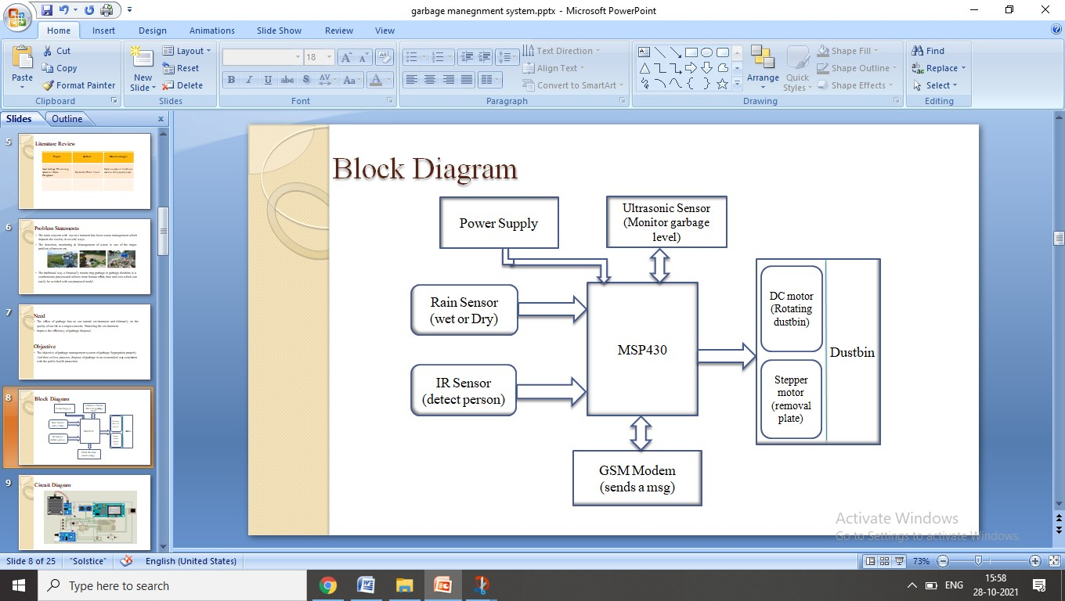

Figure 4.1 Block Diagram of Garbage Management System.

# CIRCUIT DIAGRAM

In the given circuit diagram, we are using the msp430, ultrasonic sensor sense a garbage, IR sensors which is used for detect the person, LED is used to indicate the garbage level. GSM Modem used if dustbin has full then GSM Modem sends a message to municipal office. The dustbin is full collect the garbage.

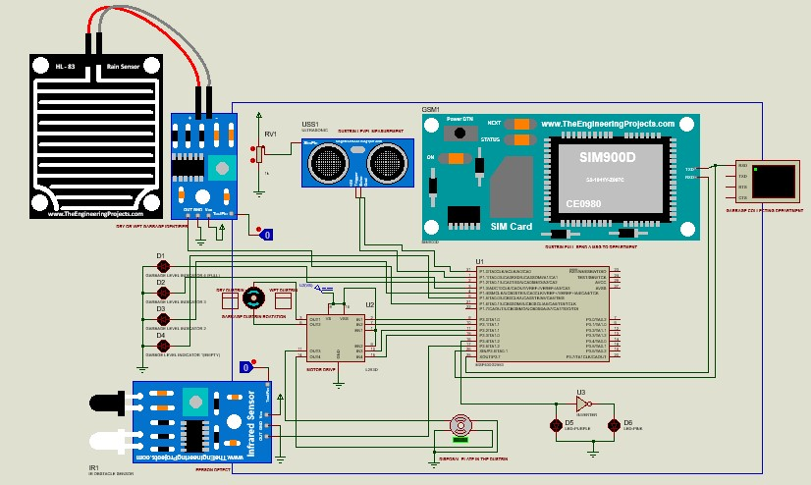

Figure 4.2 Circuit Diagram of Garbage Management System.

# CHAPTER 5

**COMPONENT DESCRIPTION**

This chapter deals with the components used in this project.

# HARDWARE

This is the list of Hardware components used to simulate this project.

Table 5.1 List of Hardware Components

|  |  |  |
| --- | --- | --- |
| **NAME OF THE COMPONENTS** | | **QUANTITY** |
| MSP430 | | 1 |
| Ultrasonic Sensor | | 1 |
| IR Sensor | | 1 |
| Rain Sensor | | 1 |
| GSM Modem | | 1 |
| Motor Drive | | 1 |
| Stepper Motor | | 1 |
| LED | 4 | |

**MSP430**

* **MSP430** is a microcontroller portfolio which offers different varieties of sixteen-bit Microcontrollers. These microcontrollers integrated with ultra-low power and digital and analog peripherals devices for sensing and measurement applications.
* This module consists of five low power modes which increase battery life in portable measurement applications.
* MSP430 has a feature of 16-bit registers, sixteen-bit RISC CPU and constant generators which provides maximum code efficiency.
* The digitally controlled oscillator (DCO) of this module converts low power modes to active mode in less than 6µs.
* The MSP430x11x series is an ultra-low power signal microcontrollers which consist of the sixteen-bit timer and fourteen input and output pinouts.
* MSP microcontrollers give ideas and enable designers to produce such high-performance applications, which support the industry’s lowest standby power, analog and digital devices suitable for sensing and measurements applications, and also support 20+ wired and wireless connectivity applications.
* Main applications which it provides are sensor system which received analog signals and converts them into digital values and after processing this data sends to host modules. Its area of applications is RF front end sensor.

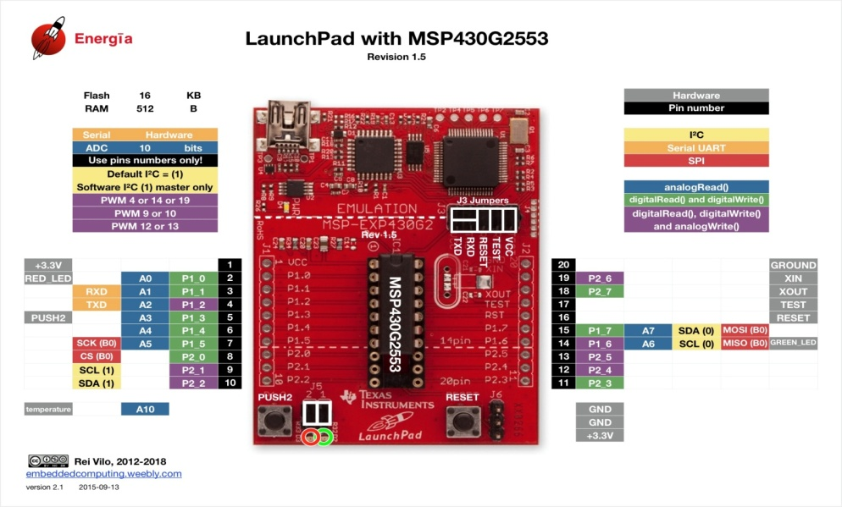

Figure 5.1 msp430

# IR sensor

IR sensor is an electronic device that emits the light in order to sense some object of the surroundings. An IR sensor can measure the heat of an object as well as detects the motion. Usually, in the infrared spectrum, all the objects radiate some form of thermal radiation. These types of radiations are invisible to our eyes, but infrared sensor can detect these radiations.

The emitter is simply an IR LED and the detector is simply an IR photodiode. Photodiode is sensitive to IR light of the same wavelength which is emitted by the IR LED. When IR light falls on the photodiode, the resistances and the output voltages will change in proportion to the magnitude of the IR light received.

There are five basic elements used in a typical infrared detection system: an infrared source, a transmission medium, optical component, infrared detectors or receivers and signal processing. Infrared lasers and Infrared LED’s of specific wavelength used as infrared sources.

The three main types of media used for infrared transmission are vacuum, atmosphere and optical fibers. Optical components are used to focus the infrared radiation or to limit the spectral response.

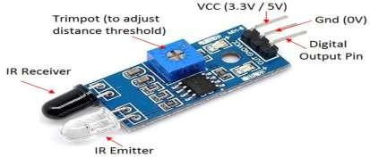

## Figure 5.2-IR Sensor

**Ultrasonic Sensor**

* HC-SR04is an ultrasonic sensor mainly used to determine the distance of the target object.
* It measures accurate distance using a non-contact technology – A technology that involves no physical contact between sensor and object.
* Transmitter and receiver are two main parts of the sensor where former converts an electrical signal to ultrasonic waves while later converts those ultrasonic signals back to electrical signals.
* These ultrasonic waves are nothing but sound signals that can be measured and displayed at the receiving end.

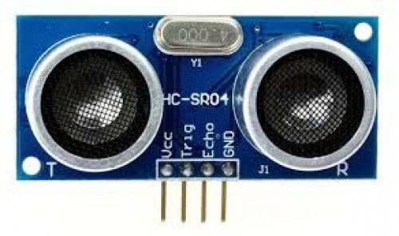

Figure 5.3 Ultrasonic Sensor

**GSM Modem**

A GSM modem is a wireless modem that works with a GSM wireless network. A wireless modem behaves like a dial-up modem. The main difference between them is that a dial-up modem sends and receives data through a fixed telephone line while a wireless modem sends and receives data through radio waves. A GSM modem can be an external device or a PC Card / PCMCIA Card. Typically, an external GSM modem is connected to a computer through a serial cable or a USB cable. A GSM modem in the form of a PC Card / PCMCIA Card is designed for use with a laptop computer. It should be inserted into one of the PC Card / PCMCIA Card slots of a laptop computer. Like a GSM mobile phone, a GSM modem requires a SIM card from a wireless carrier in order to operate. As mentioned in earlier sections of this SMS tutorial, computers use AT commands to control modems. Both GSM modems and dial-up modems support a common set of standard AT commands. You can use a GSM modem just like a dial-up modem. In addition to the standard AT commands, GSM modems support an extended set of AT commands. These extended AT commands are defined in the GSM standards. With the extended AT commands, you can do things like:

* Reading, writing and deleting SMS messages.
* Sending SMS messages.
* Monitoring the signal strength.
* Monitoring the charging status and charge level of the battery.
* Reading, writing and searching phone book entries.

The number of SMS messages that can be processed by a GSM modem per minute is very low -- only about six to ten SMS messages per minute.

## gsm-module-500x500.jpg

Figure 5.4 GSM Modem

**Rain Sensor**

A rain sensor is one kind of switching device which is used to detect the rainfall. It works like [a switch](https://www.elprocus.com/sound-activated-switch/) and the working principle of this sensor is whenever there is rain, the switch will be normally closed. The rain sensor module/board is shown below. Basically, this board includes nickel coated lines and it works on the resistance principle. This [sensor module](https://www.elprocus.com/pir-sensor-circuit-with-working/) permits to gauge moisture through analog output pins & it gives a digital output while moisture threshold surpasses. This module is similar to the [LM393 IC](https://www.elprocus.com/lm393-ic-pin-configuration-circuit-diagram-and-its-working/) because it includes the electronic module as well as [a PCB](https://www.elprocus.com/different-types-printed-circuit-boards/). Here PCB is used to collect the raindrops. When the rain falls on the board, then it creates a parallel resistance path to calculate through the [operational amplifier](https://www.elprocus.com/what-is-an-operational-amplifier-op-amp-integrator-and-op-amp-differentiator/).

This sensor is a resistive dipole, and based on the moisture only it shows the resistance. For example, it shows more resistance when it is dry and shows less resistance when it is wet.

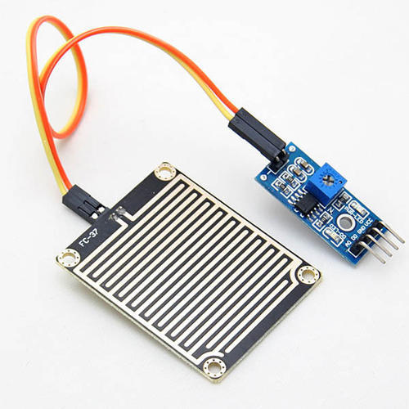

Figure 5.4 Rain Sensor

**SOFTWARE**

**Proteus-** Proteus 8 Professional is software which can be used to draw schematics, PCB layout, and code and even simulate the schematic. It is developed by Lab center Electronic Ltd. Drawing the schematic is very easy using Proteus. You can click the "Pick devices" button and select the desired component. You can draw wires by clicking on the terminal of the component or Vcc, Ground, etc.



# CHAPTER 6

**SOFTWARE IMPLEMENTATION**

This chapter deals with the software implementation part

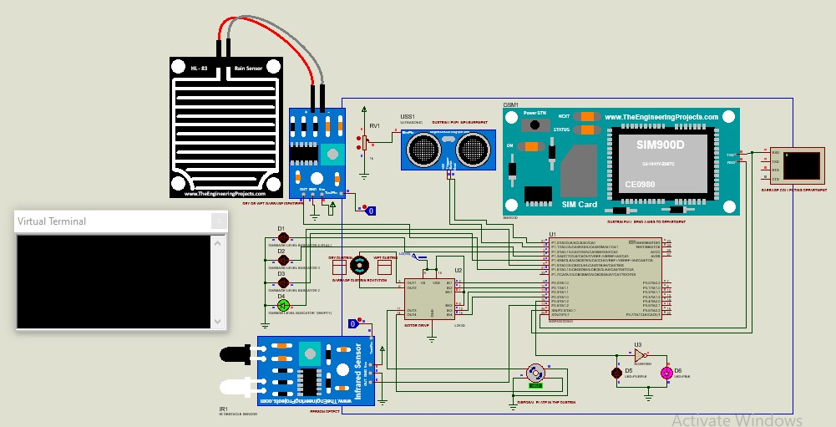

Fig 6.1 Diagram of Garbage Management System

# CHAPTER 7 SIMULATION RESULTS

Case 1: Initial State

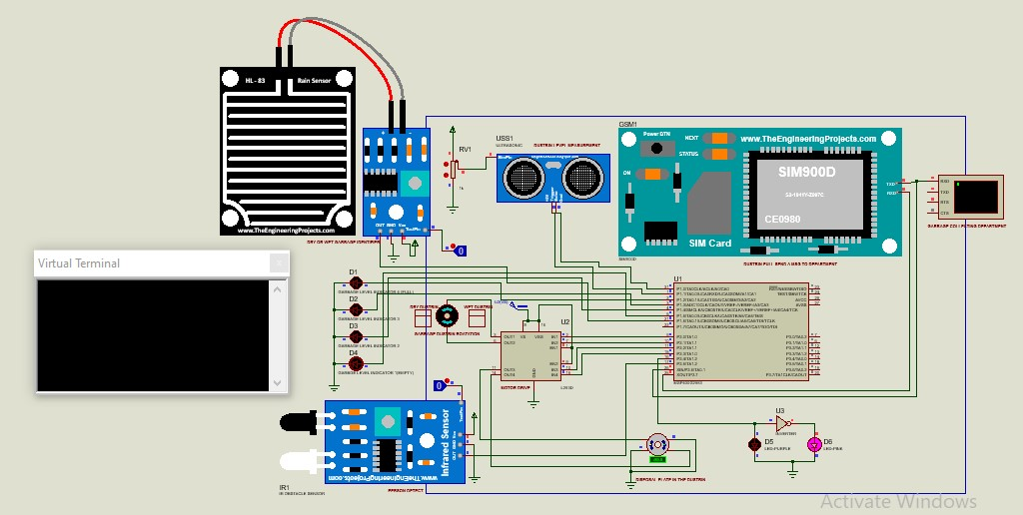

Figure 7.1 Diagram of initial state of garbage management system.

* Case 2: Working state

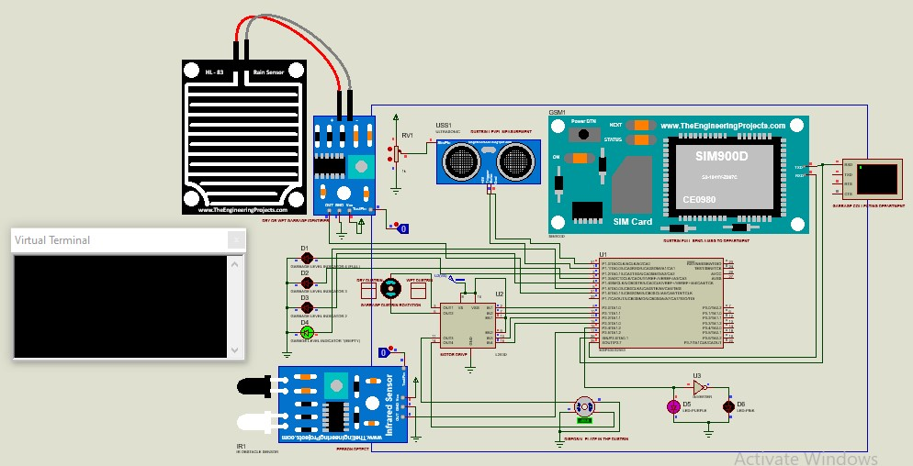

Figure 7.2 Diagram of working state of garbage management system.

* Case 3: Dustbin full sends a message to municipal office.

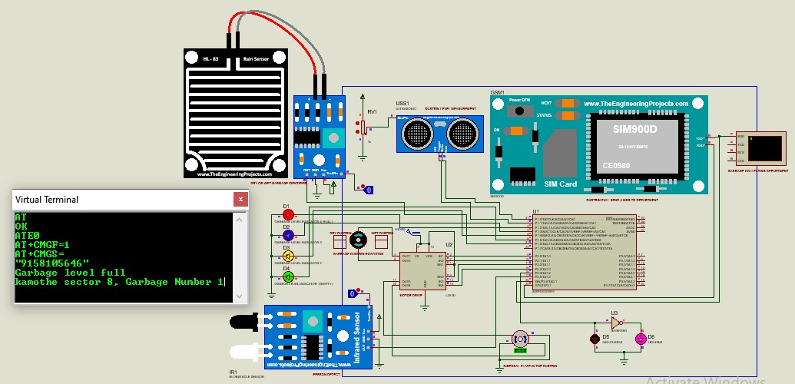

Figure 7.3 Diagram of sends a message to municipal office of garbage management system.

# CHAPTER 8 CONCLUSIONS

This chapter concludes the end results of the circuit

We built an efficient garbage monitoring system which can be used to monitor the level of garbage in the dump. This data can be further used to plan garbage collection trips more efficiently, ultimately reducing overflowing bins and helping have better public sanitation.

# CHAPTER 9 FUTURE SCOPE

This chapter tells us about the innovations which can be done using this model.

* This project is made for demo concern; it can be taken to product level.
* It can be made durable, by making it compact and cost effective.

# REFERENCES

1. Monika K A, Rao N, Prapulla S B and Shobha G 2016 Smart Dustbin-An EfficientGarbage Monitoring System International Journal of Engineering Science andComputing 6 7113-16.
2. Medvedev A, Fedchenkov P, Zaslavsky A, Anagnostopoulos T and Khoruzhnikov S,2015 Waste management as an IoT-enabled service in smart cities In Conference on Smart Spaces Springer International Publishing 104-15.
3. <https://www.gpsintegrated.com/smart-bins-for-smart-city>
4. [https://wikipedia](https://wikipedia/)
5. [www.youtube.com](http://www.youtube.com/)

# APPENDIX

